1. Please sit back and you don’t have to take any notes, because we’ll be providing you numerous short videos of everything we cover today. We’re taking the gloves off and we’re going to show you how you can adjust any set of data from any current systems such as GFEBS (Army), DEAMS (Air Force), and SMARTS (Navy and Marines). We need to mention the legacy systems too to include STANFINS (Army), CRIS (Air Force), and STARS (Navy and Marines). See below all the videos provided with the name, size, and length of each video at the very end of this document.
2. We’ll start off with a worksheet of data and walk you through four very powerful formulas that allows you to create additional answers. The four formulas are Left, Mid, Right, “&”. These four formulas are used by Analyst for years to manipulate data to get specific answers. We won’t stop there, we’ll show you an additional formula known as VLookup.
   1. VLookup, is one of the hardest formulas to get right and we want you to fully understand how it works and to always get it right. Below is screen captures of using the wizard to perform the VLookup. See below:

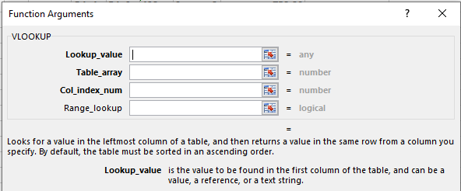

I highlighted in a blue box above 2 requirements the wizard is explaining what you must do.

1. The value must be in the leftmost column.
2. The leftmost column must be sorted in ascending order.
   1. The leftmost column value must be unique. We will use Conditional Formatting to find any duplicates.
   2. We’ll teach you how to remove duplicates.
   3. We’ll explain to you why we use dollar signs within a formula to make it an absolute reference.
      * 1. We’ll teach you how to cleanup and use an existing table.
        2. We’ll teach you how to create a brand new table.
3. Now, it’s time to create an Interactive graph. We’ll walk you through all the steps from start to finish. We’ll introduce you to two additional formulas:
   1. If
   2. Sumifs
   3. Teach how to create a list box that will be interactive with your graph.
4. Finally we’ll walk you step by step in creating a graph, using the Overlap technique that most USERs don’t know about.

