- Power Query is part of the Business Intelligence tools. It’s the least used, but this is my favorite for handling raw data. I use this for all my designs, because it’s so much easier to use and understand. The Microsoft engineers created Icons, buttons, etc. to make Power Query user friendly for all of us. You push the button, they write the code behind the scenes (We’ll show you where the code is). How easy is that? Mr. Yoder has put together a sample set of the notional data using the ZFSC5 for us to train you, but you can easily download a real ZFSC5.txt and overlay the sample data and it will work. The best part of this is that the ZFSC5 comes from the ERP system within GFEBS. You’re pulling LIVE high level Status of Funds data. We made sure one of your columns displays the Date and Time of the data so you’ll always know how current the data is. We will tell you there are many ways you can design this solution. That is the beauty of Microsoft. We need to start somewhere and I assure you this training will get you started in learning some powerful techniques. Sit back, watch our presentation and we’ll provide you short videos of how to put this together from start to finish. See picture below showing how much easier it is to learn Power Query to others.
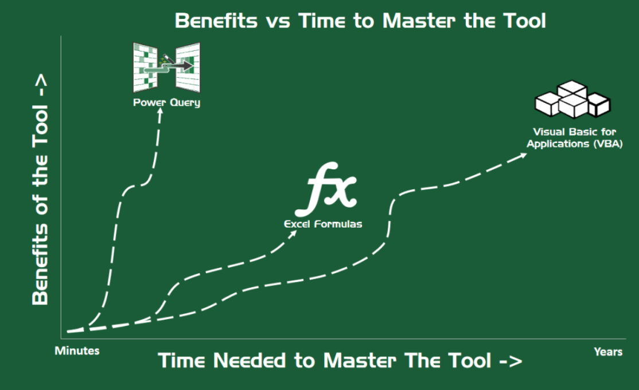
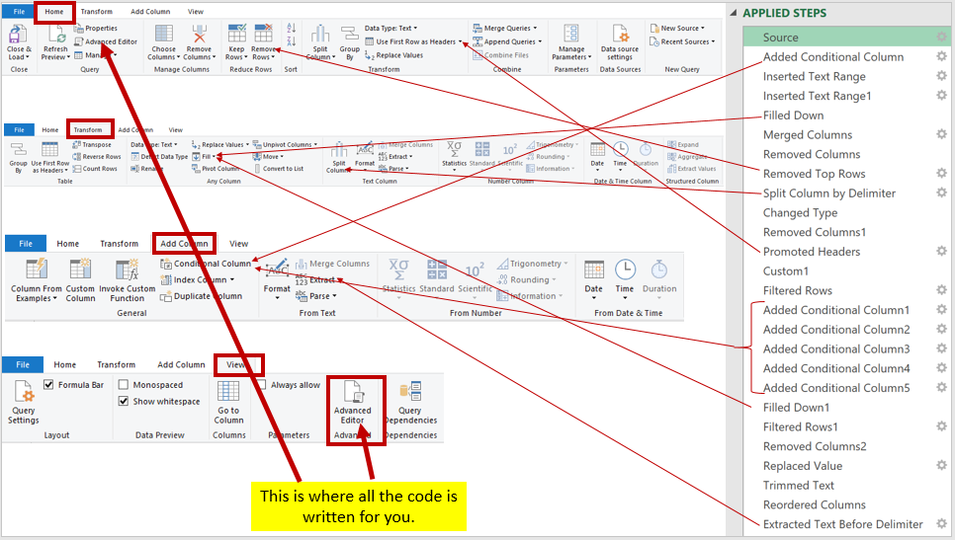

Code for Date and Time:
= Table.RenameColumns(#"Promoted Headers", {Table.ColumnNames(#"Promoted Headers"){9}, "ReportDate"})
The 9 highlighted in yellow above represents the column where the Date Time is located minus 1. Example: If the ReportDate is in column 10, then the answer is 9.
Videos Below:
