We’re excited to show you how OneNote Desktop 2016 is most unused of the Microsoft Applications, but yet one of the most powerful. We’ll empower you with solutions. We’ll conduct this training over 2 sessions, first one in October and the other in November. We’ll show you how we trained HQ PACFLT. October, we’ll explain the structure of OneNote, then we’ll add 22 customize ribbons and explain how each one works from 316 to choose from. In November, we’ll explain how you can tie your entire organization together plus more. We’re currently tying an entire FM branches from different locations around the world. Imagine, every operation in the world tied to OneNote that can be updated and shared immediately, hourly, daily, etc…

History, I first learned about OneNote from a Comptroller at Warner Robins AFB, GA around 6 years ago. I was blown away what they were doing with OneNote. Imagine, presenting a PowerPoint briefing using OneNote where Commanders, the Wing Commander, and others interacting live with each other having their own Microsoft Surface Pros Laptops writing notes where everyone at the briefing can see at once. Now, we call that today, TEAMS. They had all their previous briefings stored on the server using OneNote.

Today’s training we’re going to show all of you how we trained and “TIED” together HQ PACFLT (We trained those around 4 years ago) using OneNote. We briefed the Chief of Staff that would go out to every single person (over 100 plus) one on one to setup and get them started with OneNote. After we provided training, we were blown away of how the Navy Commanders and others designed and tied together their entire organization using OneNote. Imagine, one of their designs, they had all their High, Medium, and Low Taskers displayed to let everyone know where they stood and kept senior leaders informed. Everyone was tied to a live Notebook that was updated as Taskers were completed. OneNote provides a great summary page showing what Taskers are still open, instead of looking through all the Sections and Pages to view individually. We’ll show you that great feature today or next month.

We started their training by first breaking down OneNote, explained OneNote is broken down into three sections. First section is the Notebooks, second section is Sections (We like to call it Chapters) within each Notebook, and finally the third section is pages within each Chapter. See illustration below.

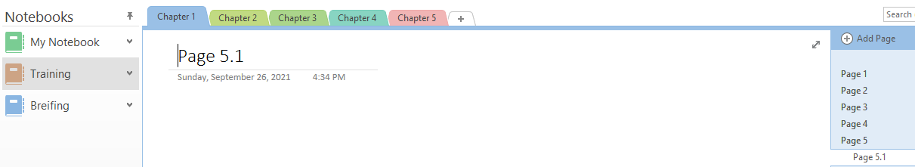

Page

Chapters

Notebook

Secondly, we setup a personal tab for each person in OneNote, using Customize Ribbons. We started them off with 20 tips to help them get started and showed them how they worked. We added 2 more tips, to make it a total of 22 tips. See Below.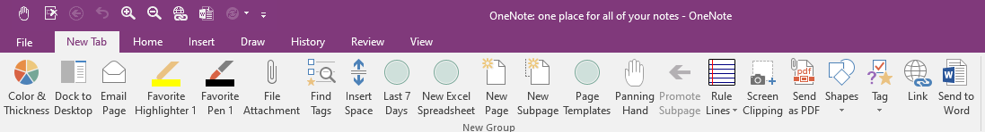

Third, we added Training Notebook to every single person we setup, so I can keep the entire HQ PACFLT we trained informed. It also gave them a sample to learn from. It also taught them that they can do the same thing for their organization. We added “Teksouth_Training” notebook in the zipped file. Video #23 will walk you through how to add to your OneNote as a Notebook.

Important Tip: 1) You never have to do a “Save”, because OneNote saves everything once entered. 2) You will go back to the exact place you left, when reopening OneNote. 3) CTRL + Z is undo

We’ll be providing an Excel cheat sheet showing all 316 “All Commands” shortcuts in OneNote 2016 Desktop version.

As always we’ll provide several short videos below of our training, so sit back and enjoy the training. See below:

