- Header Styles
- Auto Generate Table of Contents
- Highlight all instances of a Word
- Editor
- Compare Two Documents

Header Styles

Headings, located on the Home tab of the ribbon, are readily available styles you can apply. They make text easily stand out and enable you to quickly build a table of contents and use the navigation pane. They can be customized by right-clicking on any of the headings and selecting ‘Modify’.
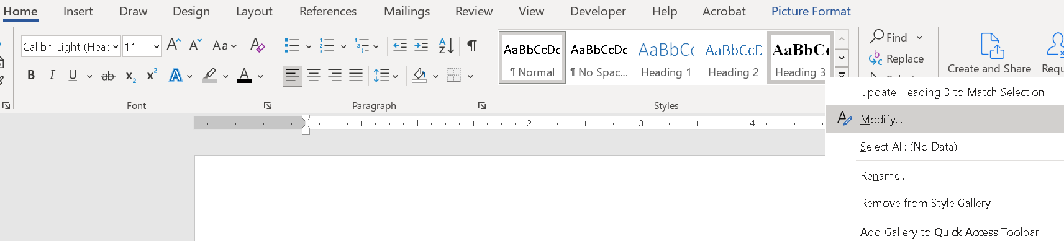

You can expand and collapse groups of text by right clicking on any of the headings.
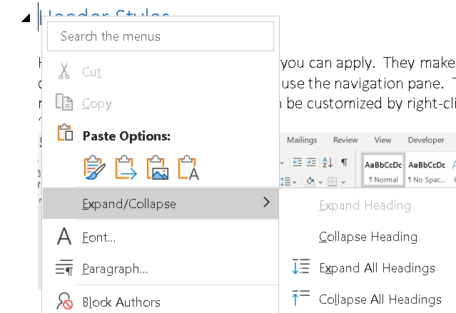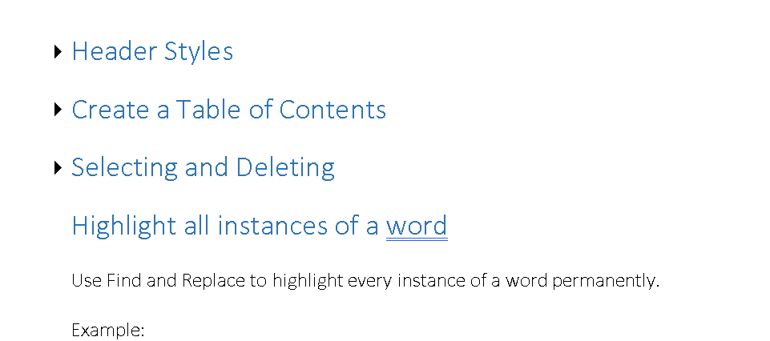

To turn on the Navigation Pane, go to the View Tab on the Ribbon and check mark ‘Navigation Pane’.
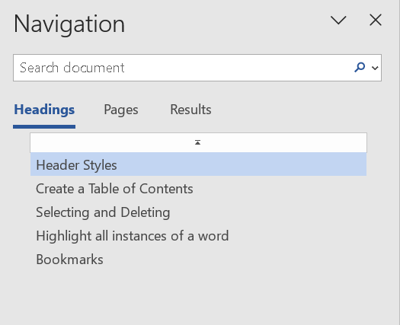
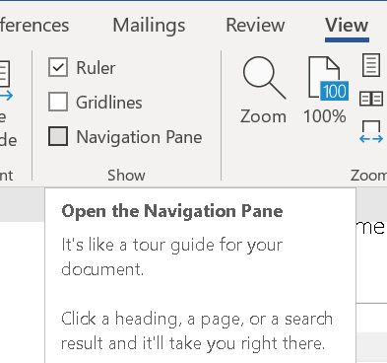

Example
Select all topics in this tips & tricks word document and click ‘Heading 1’. PRO TIP: Zoom the document out so you can see all of the pages at once. Hold down < Ctl > as you select the text, so you can select all of them at once.

Create a Table of Contents

A table of contents in Word is based on the headings in your document. Table of contents automatically creates links between the table of contents and the individual headings. Page numbers will not update automatically. If you make changes to your document that affect the table of contents, you must click ‘Update Table.’ Expanding / Collapsing headings will affect page numbers.

Example
Put your cursor where you want to add the table of contents. (Page 2 of this document)
Go to References > Table of Contents > choose a style.

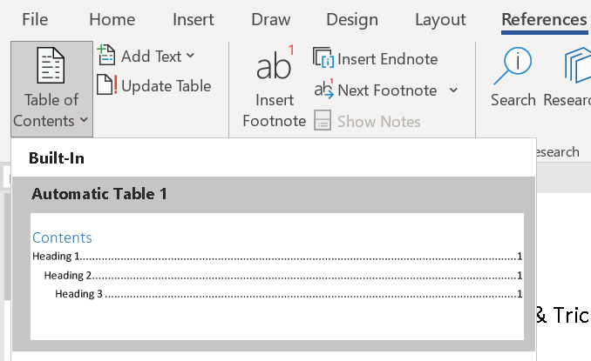

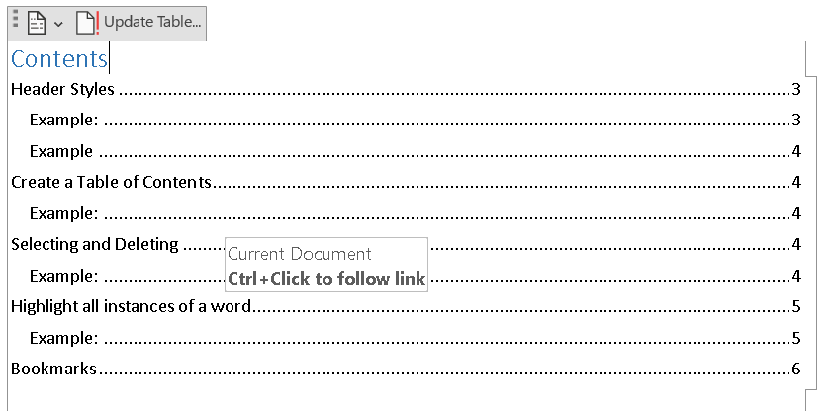

Highlight all instances of a word

Use Find and Replace to highlight every instance of a word permanently.

Example
- Set the highlight color by selecting it on the Home tab of the ribbon.
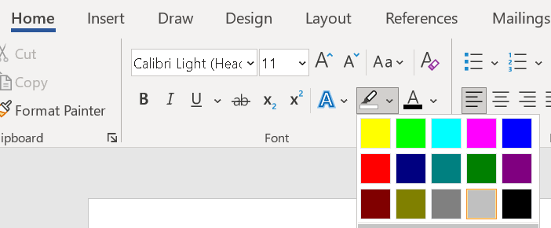

- Click < ESC > to turn off highlight mode
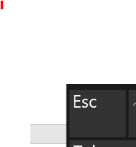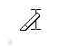

- Open Find and Replace < Ctl > + < H >
- Expand the ‘More >>’ Menu
- Type the word you want to highlight in both ‘Find what’ and ‘Replace with’
- Ensure you are clicked in the ‘Replace with’ text box
- Click the drop-down menu for ‘Format’
- Select ‘Highlight’ and click ‘Replace All’

Header Styles Part 2

Example
Make every instance of the word Heading 2. Then refresh the table of contents.

You can use ‘Find and Replace’ and the ‘More’ Menu to do this quickly:
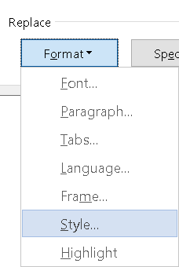
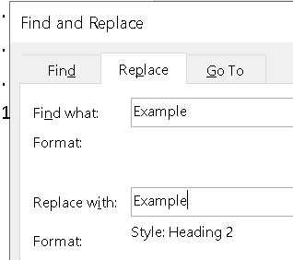
- Open Find and Replace < Ctl > + < H >
- Expand the ‘More >>’ Menu
- Type in both ‘Find what’ and ‘Replace with’
- Ensure you are clicked in the ‘Replace with’ text box
- Click the drop-down menu for ‘Format’
- Select ‘Styles’ and Heading 2
- click ‘Replace All’

Now update the table of contents:

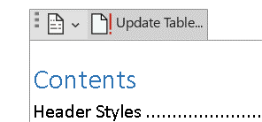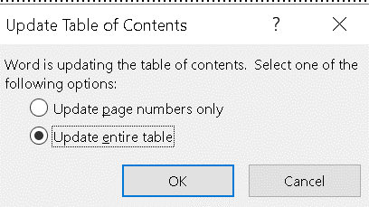

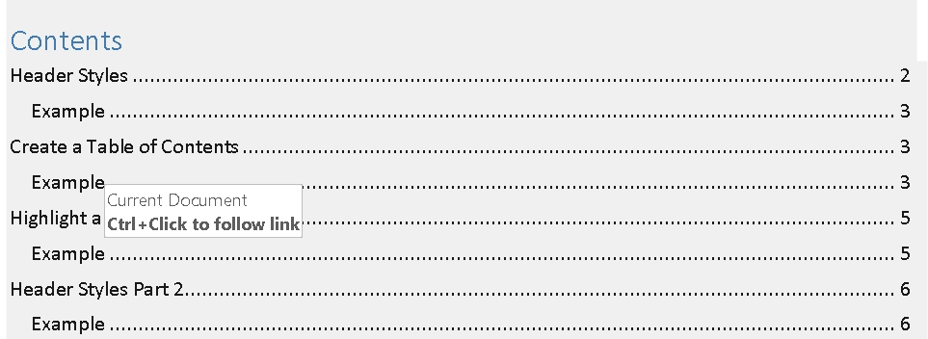

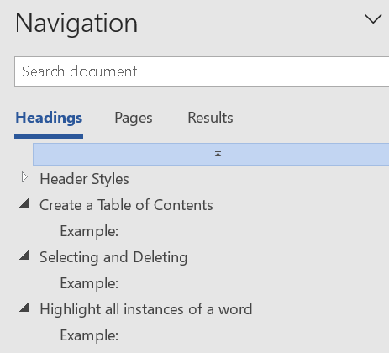

Review the Navigation Pane and see how easy it is to navigate, expand and collapse through the different levels.

Editor

The Editor feature is a comprehensive writing assistant powered by AI technology. It analyzes written content and offers advanced proofreading and editing suggestions, including grammar, spelling, readability, clarity, and conciseness.

To adjust proofing settings:
File > Options > Proofing > Settings in ‘When correcting spelling and grammar in Word’ Section

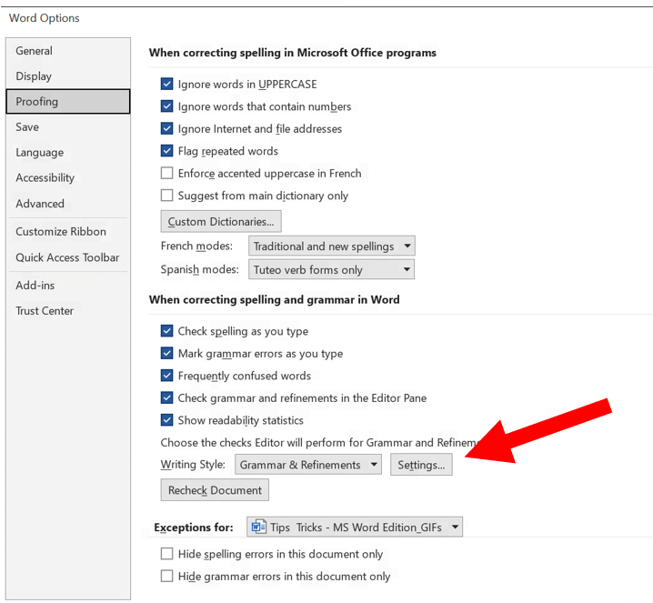

Editor can be located on the right of the Home Ribbon > Editor or by clicking the hotkey F7.

If blocks are grayed out, no suggestions were found. Click on the block you’d like to review.

To see ‘Readability Statistics’, click on ‘Document Stats’ under ‘Insights’.

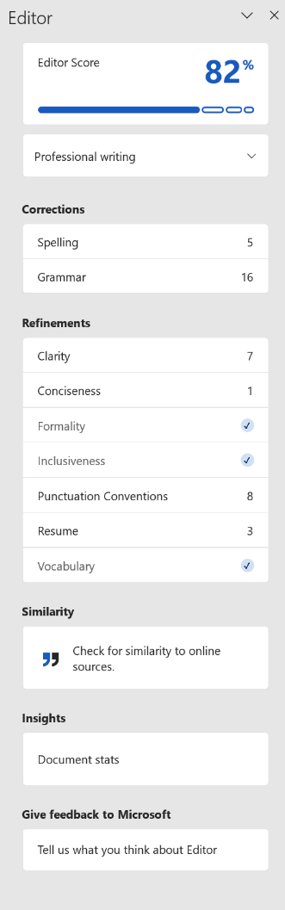
Editor score is a measure of how well your document has been edited based on the number and type of suggestions provided by the Editor. It’s calculated by counting the number of errors and style suggestions and comparing it to the total number of words.
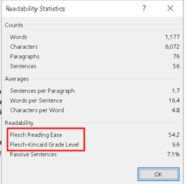

Writing Style complexity ratings:

Flesh Reading Ease
- 100-point scale
- The higher the number, the easier to understand
- Recommend aiming for above 60

Flesh-Kincaid Grade Level
- Indicates US grade level text is written for
- Recommend aiming for 7.0 to 8.0

Compare

You can compare two versions of a document to see how they differ. You can also merge two versions of the same document into one new document. In both cases, Word shows the differences with revision marks. It’s located on the ‘Review’ tab of the ribbon.

Example
